TO HIEN THANH PRIMARY SCHOOL
INTENSIVE ENGLISH PROGRAMME
FAMILY & FRIENDS 2 (Special Edition)– WEEK 26
UNIT 10: A NEW FRIEND!
- Draw and color yourself.
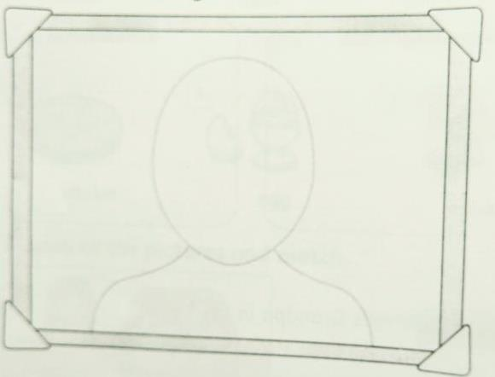

- Look at your picture. Read and circle
blue brown green black
- My eyes are
black brown red
- My hair is
straight curly
- My hair is
long short
- My hair is
3. Read and write .
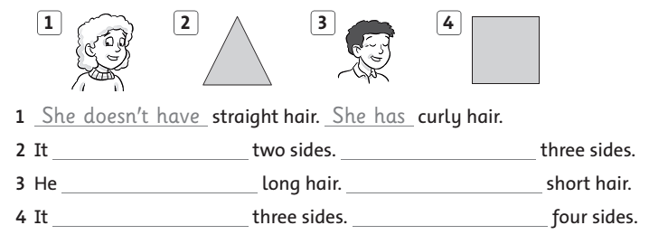

4. Unscramble and draw.
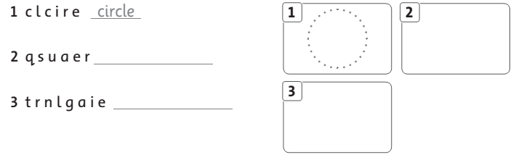

- Chúc các em làm bài tốt -
ANSWER KEYS
- Draw and color yourself.
- Bạn nhìn vào gương và vẽ mình nhé.
- Dưới đây là ví dụ về Ms.Ha.
Ms.Ha



- Look at your picture. Read and circle
black
blue brown green
- My eyes are
black
brown red
- My hair is
straight
curly
- My hair is
long
short

- My hair is
3. Read and write .
2. doesn’t have - has
3. doesn’t have - He has
4. doesn’t have - It has

- Unscramble and draw.
2. square

3. triangle

